Information Technology Solutions

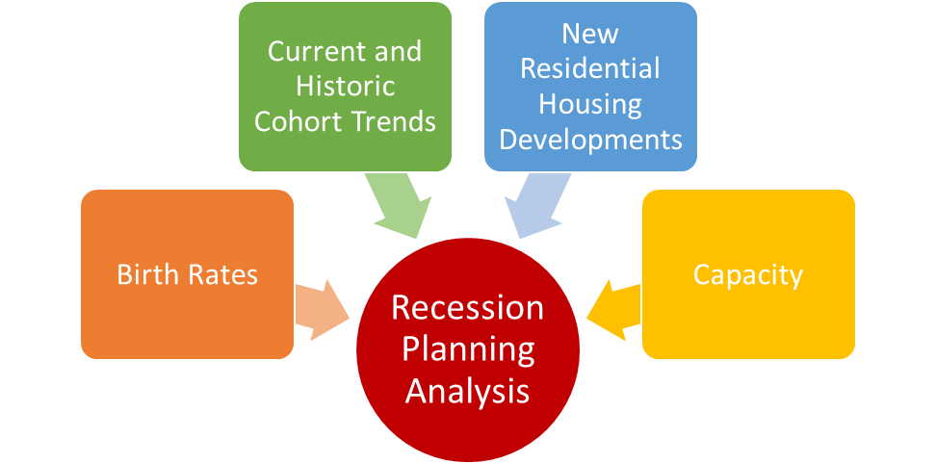

SchoolWorks, Inc.

8331 Sierra College Blvd, #221

Roseville, CA 95661

Recession Planning Analysis

* Utilizes trends from the previous recession
* District and individual school six year projections
* Current and projected utilization chart

A Recession Planning Analysis provides an analysis of student enrollment for the entire district and each individual school. Projections will show current vs recession trends.

A Recession Planning Analysis includes:

* District map
* Historic kindergarten capture rates
* Historic enrollment and cohorts
* Classroom counts and capacity
* Six year enrollment projection
* School facility utilization
* Individual school enrollment projections

**Specifically created for districts with 500 to 5,000 students**

**INPUT FACTORS**

**BIRTH RATES**

Local birth rates are used to project future kindergarten enrollment.

**COHORT TRENDS**

Historic cohort trends from the last recession wll be applied. Four years of historic CBEDS/ CalPADS enrollment will be utilized for current trends.

**NEW HOUSING**

To determine the impact of new housing developments, each new housing unit is multiplied by the student yield rate.

**CAPACITY**

The classroom counts represent the rooms that can be used for teaching purposes at each school site. To get the capacity we mulitply loading standards by the number of teaching classrooms.